TEST SUMMARY REPORT
Restful Booker API — QA Testing Cycle

Project: | Restful Booker API
Report Type: | Test Summary Report
Testing Period: | April 13 – April 16, 2026
Environment: | Postman
Total Test Cases: | 84
Prepared By: | QA Team (Hamza, Fadi, Hassan,moneera)
Report Date: | April 2026

1. Executive Summary
This report presents the results of functional API testing performed on the Restful Booker API. The testing covered all major API endpoints including Authentication, Booking CRUD operations, and Health Check. A total of 84 test cases were executed across three environments over a three-day testing cycle.

Total Tests | Passed | Failed | Pass Rate
84 | 71 | 13 | 85.7%

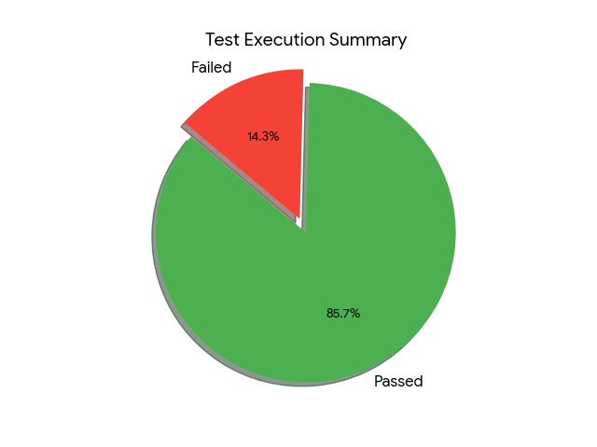

2. Test Scope & Coverage

2.1 Modules Tested
# | Module | Total | Pass | Fail | Assigned To
1 | Authentication (POST /auth) | 8 | 8 | 0 | Hamza
2 | Get All Bookings (GET /booking) | 11 | 11 | 0 | Team
3 | Get Booking by ID (GET /booking/:id) | 11 | 11 | 0 | Team
4 | Create Booking (POST /booking) | 12 | 7 | 6 | Fadi
5 | Update Booking - Full (PUT /booking/:id) | 14 | 11 | 4 | Fadi
6 | Update Booking - Partial (PATCH /booking/:id) | 17 | 14 | 3 | Hassan
7 | Delete Booking (DELETE /booking/:id) | 10 | 10 | 0 | Hassan
8 | Health Check (GET /ping) | 2 | 2 | 0 | Hamza

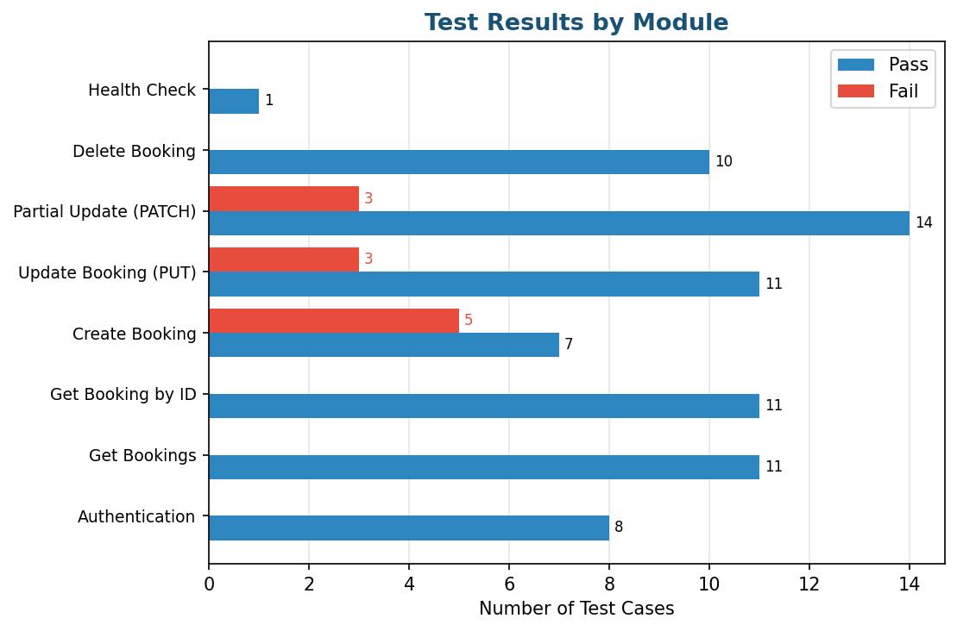

3. Defect Analysis

3.1 Defect Summary
A total of 13 defects were identified during the testing cycle. The majority are high-severity issues related to inadequate input validation across Create Booking (POST) and Update Booking (PUT/PATCH) endpoints.

Bug ID | TC ID | Title | Priority | Severity | Assigned
B01 | TC-070 | PATCH: Excessively long firstname accepted | Low | Low | Hassan
B02 | TC-071 | PATCH: Unsupported fields ignored silently | High | Medium | Hassan
B03 | TC-036 | POST: Booking created with empty firstname | High | High | Fadi
B04 | TC-037 | POST: String accepted for totalprice field | High | High | Fadi
B05 | TC-038 | POST: Checkout earlier than checkin accepted | High | High | Fadi
B06 | TC-039 | POST: Negative totalprice accepted | High | High | Fadi
B07 | TC-040 | POST: Non-existent dates accepted (NaN) | High | High | Fadi
B08 | TC-041 | POST: Zero totalprice accepted | High | Low | Fadi
B09 | TC-051 | PUT: Negative totalprice accepted | High | High | Fadi
B10 | TC-053 | PUT: Update succeeds with empty firstname | High | High | Fadi
B11 | TC-054 | PUT: Checkout earlier than checkin accepted | High | High | Fadi
B12 | TC-055 | PUT: String format date accepted (NaN output) | Low | High | Fadi
B13 | TC-068 | PATCH: Invalid data type (string) accepted | High | High | Hassan

3.2 Defect Distribution Charts
Priority Distribution  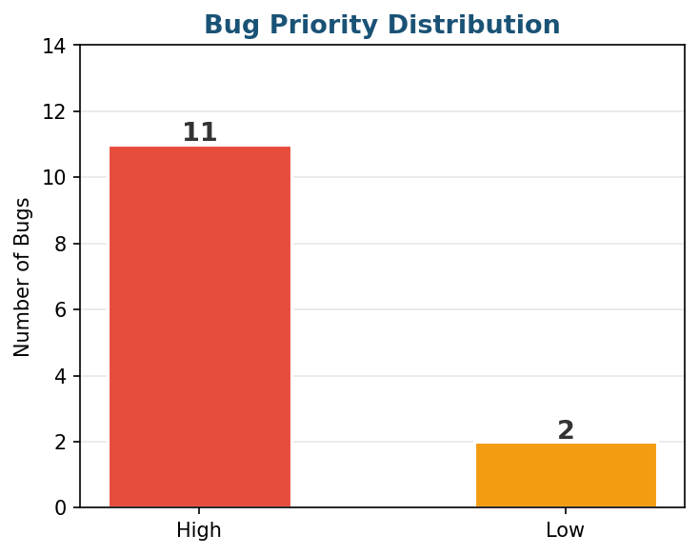 | Severity Distribution  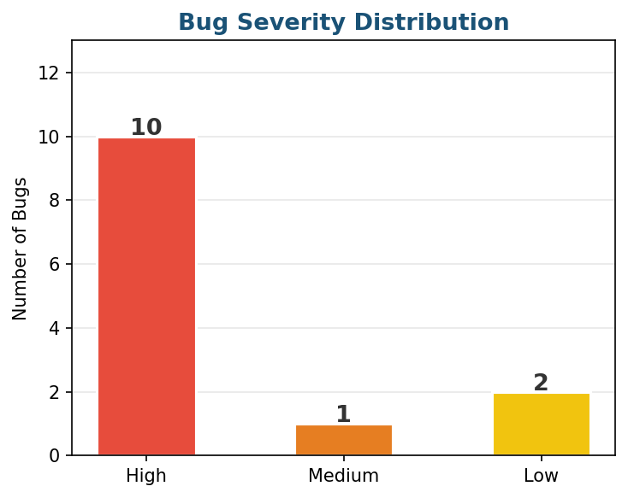

Bugs by Tester
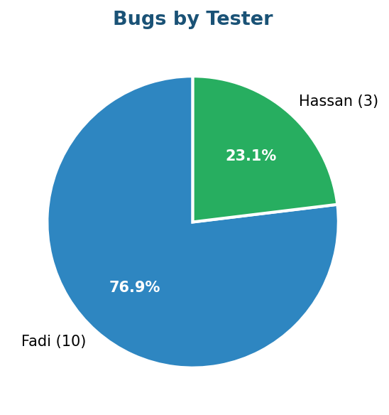

4. Key Findings & Observations

4.1 Critical Issues (High Severity)
The API lacks robust input validation across multiple endpoints. The following critical patterns were observed:

# | Finding | Impact
1 | Missing required field validation | POST and PUT endpoints accept bookings with empty firstname, enabling creation of invalid records.
2 | No date logic enforcement | Checkout dates earlier than checkin are accepted, causing logically invalid bookings.
3 | Invalid data type acceptance | String values for numeric fields (totalprice) result in null values or unexpected behavior.
4 | Negative & zero price allowed | No validation prevents creation/update of bookings with negative or zero total price.
5 | Malformed date handling | Non-existent dates are stored as "0NaN-aN-aN" instead of returning an error.
6 | Unsupported fields silently ignored | PATCH endpoint accepts unknown fields without any validation error (B02).

